Mini Motorized Car Wash and Dryer Machine

Washing the cars is a tedious job for car owners. Just drive past any car wash on a weekend and you’ll see cars lined up expecting their turn within the wash tunnel. We have to pay to get our car washed, but why pay the expensive price of a professional when you can get the same results doing it yourself. Using this Portable car washer users can easily wash their vehicles.
The car washer works on the principle, i.e., water and solution are released with pressure from the nozzle and water can be released either individually or with the solution. This device discloses a brush mounted in a handle with water and detergent, or soap, inlet means and means to discharge the water, with or without the soap, onto the brush. The main intention of this product is that the sponge type brush is rotated with the assistance of an electrical motor which is fitted into the handle or the nozzle.
Another criterion used in this device is that the pressure and the speed of the water flowing or coming out through the nozzle can be controlled during the washing and rinsing of the vehicle. Also, the solution and the water are separated with two different pipes that come in the nozzle or handle through the pump. After the vehicle is washed with soap or detergent suds the vehicle could also be rinsed by isolating the availability of soap or detergent.
Components:
- Water Pump
- Water Tank
- Hose Pipe
- Water Spray Gun
- Nozzle
- Pipe Connector
- Car Charger connector
- Shaft
- sponge
- motor assembly
- Brush

Advantages:
- It has multiple attachments in one device
- It sprays and brushes simultaneously.
- Water tanks have wheels, which will help the tank to move easily.

Disadvantages:
- Its water flow pressure is limited.
- This device can drain a car's battery.

Block Diagram

Washer Attachment 1
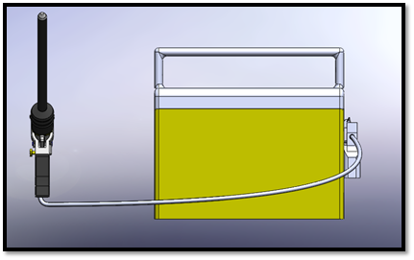
Washer Attachment 2
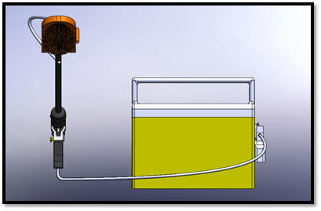

Washer Attachment 3
